|  |
| --- |
| **C:\Users\alund\Pictures\County logo_TIF.tif Whatcom County Health Department**  **Tuberculosis Program** |

**DOT Dose Count Record**

Name\_\_\_\_\_\_\_\_\_\_\_\_\_\_\_\_\_\_\_\_\_\_\_\_\_\_\_\_\_\_\_\_\_\_\_\_\_\_\_\_\_\_\_\_\_\_\_ DOB\_\_\_\_\_\_\_\_\_\_\_\_\_\_\_\_\_\_\_\_\_

|  |  |  |  |  |  |
| --- | --- | --- | --- | --- | --- |
| **Dates** | **DOT**  **Doses** | **Reported Doses** | **Missed**  **Dosses otal** | **Held Doses** | **Dose Totals daily 3 x wk** |
| Hospital / Other LHJ Transfer Dose Totals |  |  |  | **Dates** |  |
|  |  |  |  | **Dates** |  |
|  |  |  |  | **Dates** |  |
|  |  |  |  | **Dates** |  |
| **Intensive Phase Totals (56 daily)** |  |  |  |  |  |
| **Change to 3X wk? Date** |  |  |  |  | **Daily 3X wk** |
|  |  |  |  |  | **Daily 3X wk** |
|  |  |  |  |  | **Daily 3X wk** |
|  |  |  |  |  | **Daily 3X wk** |
| **See Extended Therapy sheet for Tx > 6 mo** |  |  |  |  | **Daily 3X wk** |
| **Continuation Totals: 3X wk = 54, daily =126** |  |  |  |  |  |
| **Total Regimen Intensive + Continuation** |  |  |  |  | **% DOT\_\_\_\_\_\_\_** |

To calculate % DOT, subtract **Standard: Total Regimen** **daily**  **= 182 doses**

#doses DOT then \_XXX\_

— # reported divide # DOT X 100

XXX = % DOT

— # doses DOT

— # doses DOT

# reported doses from # DOT **3X wk Continuation = 110** **total doses**

See Table over

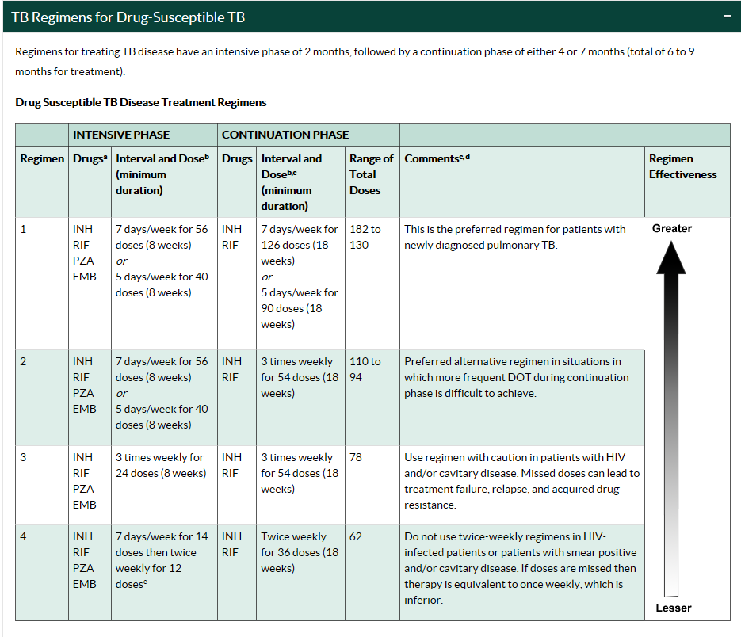

I: \CD & E\Prevention & Screening\Tuberculosis\Active TB Clinical Management\DUMP ACTIVE Active TB Case Initiation Forms & Handouts\Medication DOT Forms & References\DOT Dose Count with CDC Table 9-18.docx