KARDIA START UP INFORMATION

Procurement: Maria Gomez is responsible for ordering these devices for the counties when BPaL regimen is initiated.

The links below should address everything from start up to apps, the actual hardware, troubleshooting and FAQs. There is also information about the smart devices that are compatible with Kardia.

The patient does have to create a free account, but they do not have to pay for a subscription or reading. Once they complete the EKG, there should be an option to “Share PDF” as seen in the snip below.  Please have the patient share the PDF with the nurse case manager, and then the NCM can share it with Dr. Ashkin to do the QT measurements. Dr. Ashkin can train the local provider to do this as well, if needed. In the message, please have them include the patient’s name, DOB, and state ID.

Here are a couple of links that were helpful from the manufacturer’s website and a snip from a YouTube video that showed the EKG app display:

* [AliveCor Support (zendesk.com)](https://alivecor.zendesk.com/hc/en-us) – FAQs page
* [Getting Started – AliveCor Support (zendesk.com)](https://alivecor.zendesk.com/hc/en-us/categories/204263208-Getting-Started) (includes FAQs, such as the information about creating the account and paying for services, etc.)
* [Our Devices | AliveCor](https://clinicians.alivecor.com/our-devices/) (demo video – click Kardia 6L “See how it works”)

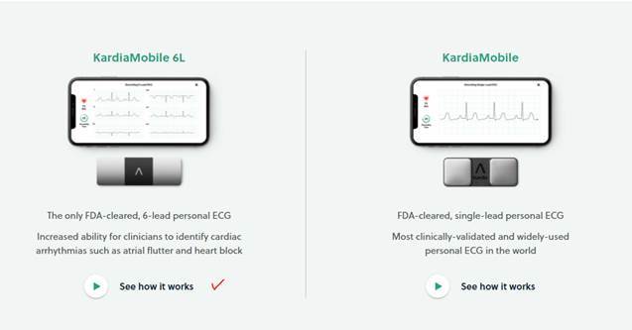

Here is a snip that shows the sharing option.

