Highlights from July 24th NTNC member meeting. Topic of discussion was the US TB nurse perspective on The Union-NAR and CITC sponsored webinar, Reframing Directly Observed Treatment, originally offered as part of the 2025 NAR conference and broadcast via webinar on May 7, 2025.

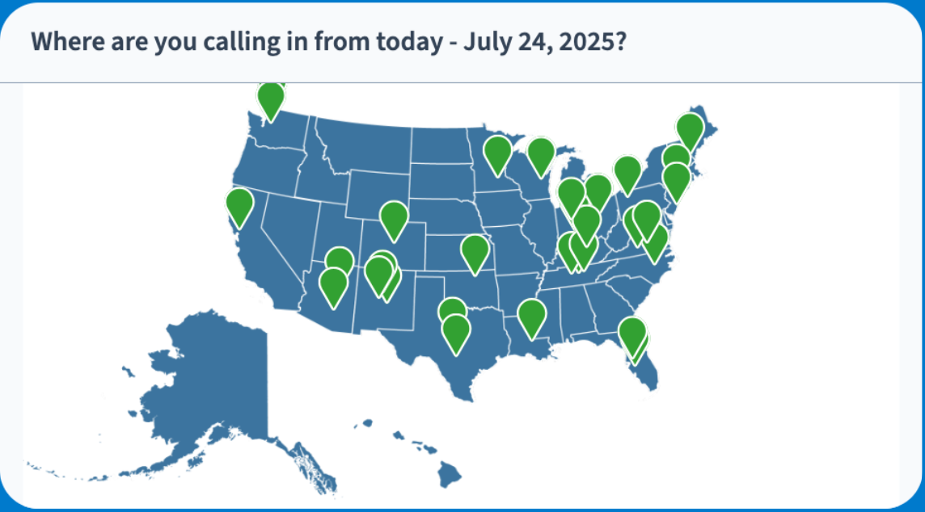
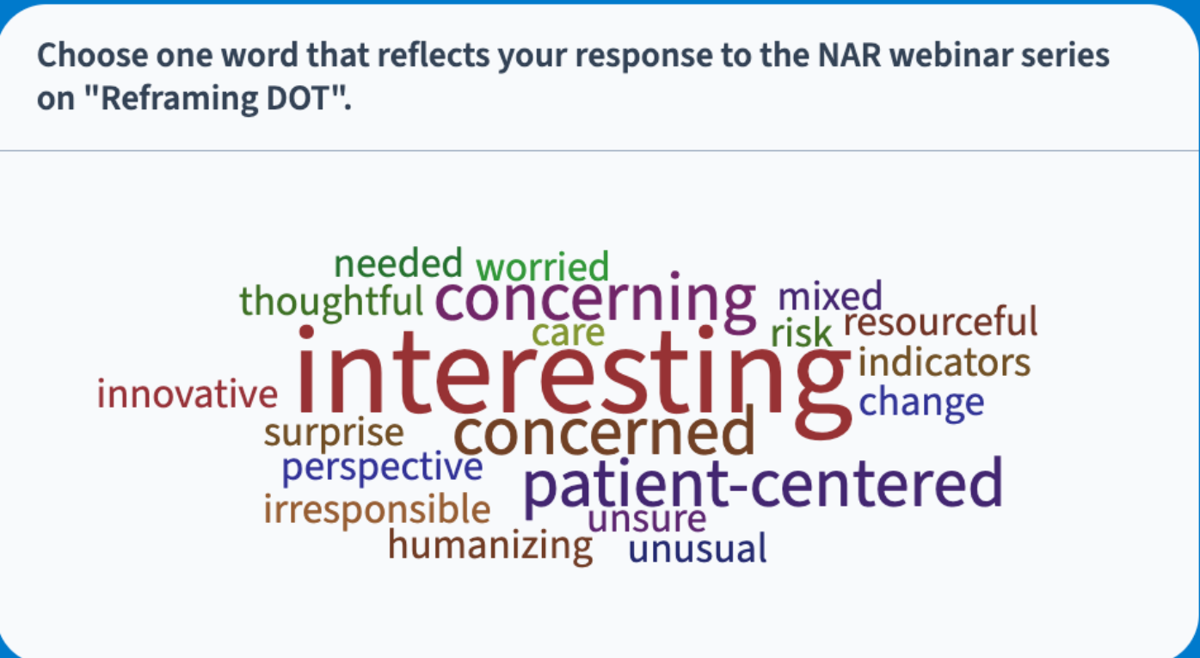

In summary, TB nurses aim to provide a patient center approach, without losing the benefits of case management including DOT. There are many ways to provide DOT that are patient centered, including video DOT. The key is making DOT part of patient centered care and incorporating wrap around services. There is also a need for data to show the impact of DOT on public health and patient outcomes in the US.
Of note, one reason DOT may be needed more in the US is the lack of a health care safety net and the lack of access to combination therapy available elsewhere in the world. In addition, electronic DOT options address much of the concerns raised by this webinar, providing a balanced approach to patient centered care that promotes safe treatment completion.

To quote from a 2018 editorial that still remains relevant, the evidence. . .should spur individual programs to personalize multicomponent packages of support for their patients. These should include DOT for most, along with patient education, incentives/enablers, and others. Programs should personalize these packages of support taking into account the particular needs of patients in the context of particular programs. . . Meeting that goal means moving beyond debating whether DOT works (it does) to the broader needs of patients and families affected by TB.

Initial Response:
- HIV has so many more resources than TB
- I was surprised that Canada doesn't routinely do DOT.
- And for reflections on the actual webinar, I felt like a lot of the indictment around DOT was based on international experiences of facility-based DOT where the patient has to come to you... And didn't necessarily recognize the ways that we try to make DOT fit better into folks' lives, for instance through asynchronous vDOT
- Presentation also failed to address the public health component of DOT.

Are there individuals that you do NOT provide DOT to? How do you decide?
- We buy phones, use self administration hybrid with eDOT, use community health workers for DOT, etc.
- No DOT for 3HP. All TB disease have DOT in OR.
- We do DOT for all active; electronic or in-person.
- 3HP gets DOT
- NC does not do DOT for 3HP and 1HP. otherwise, all active TB cases and all ages are observed
- VDOT for high risk LTBI, Kids, HIV and all TB Cases
- No DOT for LTBI except for children. V-DOT for all active cases
- The majority of our county LHJs do DOT for all TB disease cases, but our largest county with the highest burden does not do DOT for DS EPTB cases.
- We do DOPT for 3HP and peds and DOT for active cases; but it is in legislation that DOT is required for infectious TB disease, and recommended to extrapulmonary, but not mandated.
- all active for WI, 3HP for people on dispensary. I feel like the DOT connection opens the door for other resources. We dont get good outcome/communication for LTBI not on 3HP so I kind of wonder how easy it would be to get updates on active without the DOT connection.
- Some counties do in-person one day a week and vDOT the other 6.
- we use vdot...not willing to switch to something not DOT
- KY offers VDOT at start of Continuation phase.
- Everyone gets DOT as a starting point

How do you decide?
- Stable housing and work, social supports, well tolerated treatment, regular follow up with ID, rockstars at DOT, etc.
- Living on a ranch 60 miles out of town
- I would not be a high risk for non-adherence based on those factors, but I am horrible with medication/vitamins so I would fall off the treatment fast.
- That would be prejudging and guessing. I do not recommend judging based off of behavior, group, or resources.
  - I agree. demographics aren't predictive
  - Yup. I had a coworker who decided that she only needed half doses of antibiotics after dental work because of a health belief model. she asked me why she had yellow discharge. this was someone with a MPH
  - You cannot judge--that is prejudging and will be treating people differently. I can see that as opening litigation concerns.
  - right. that would be harder to defend in legal systems
- Ocular TB, patient choice
- If we can't see a client everyday for whatever reason, but we aren't comfortable yet putting them on VDOT, we do virtual visits.
- I feel like the Canadian system is different enough that it may not be generalizable to the US with the same results.
  - For instance, Canada moved to SA; however, they had less than 2,000 cases last year
  - their system also seems more cohesive? in Wisconsin we have such a mix of private clinics... no consistency
  - I am going to assume (bad, I know) that Canada has extremely low incidence yet TB disproportionately affects their First Nations peoples. Targeted culturally specific DOT might be a benefit in reducing disparity.
  - Agreed, TT could be a different model/standard for DOT vs SA
  - I've always wondered, does Canada publish their rates of TB treatment completion and relapse?
- MA is definitely more relaxed about DOT for TB disease than other states that I've worked in before. Sometimes, based on how things are going, DOT is rolled back later in treatment. So in continuation phase, someone may have once weekly phone "adherence support," or vDOT 2-3 days per week and SAT for the other days. It's a bit mixed
- Maybe only require DOT once a week for those folks to touch base
- No, we do not discontinue DOT for anything, but may switch to vdot if they have capability and meet our criteria.
- I would want some sort of support, like pill boxes
- i feel like the continuation phase is when we have the most treatment adherence issues because they're feeling better and don't think treatment is as important
- I'm concerned about coming up with a fair demographic for not requiring DOT. Is there a risk of creating a DOT system that appears to "punish" patients without stable housing, etc.?
- I am grossly concerned over the push to relax all aspects of TB case management when we have proven methods for the past number of decades.
- Staffing is going to eventually result in no DOT for some counties.
- Wyoming has such scarce access to services and resources. Fortunately, our morbidity is low enough that we can evaluate each scenario and make the best plan to support the patient and treatment outcomes.
  - And I think that speaks to the importance of nurse case managers in getting to know and forming a relationship with our patients
- I would not be comfortable removing DOT requirement in the population that we serve
- There are many ways to deliver TB medication. eDOT, Community outreach, schools, EMT/Paramedics, School Based Health Clinics. The future of Public Health is building collaborations and partnerships and working together
  - NM Partnered with Pharmacist to deliver 3HP DOT.
  - Same in Ky, we have used pharmMDs
  - Would love to know what tech can dispense and capture video of patient taking meds- without a contract
- I do think that we are responsible to challenge public health approaches that burden patients and I have always wondered how the US healthcare delivery system, or lack there of, impacts the need for this enhanced case management that included DOT.
- I agree on equity concerns. Seems like wealthy people would get no DOT while others DOT
- I never make it a "required conversation" I always let them know that I have my role and they have theirs. Together we work toward curing. Its never a legal required conversation. Its a mutual agreement.
- I think the growing availability for VDOT options relieves much of the DOT work burden for our programs and patients
- Yes, Ann!! The standard needs to hold and other resources need to be brought in to make it happen. If DOT is a burden to multiple areas, then maybe states will put more money into TB control.
- I also think about one of the TB survivors who spoke so eloquently at the ETN/PEN conference. She did have DOT, but she also had more hands-off nurse case management style. She probably could have completed SAT successfully. But she spoke about how much she would have appreciated more wrap-around support, including emotional support and monitoring for adverse med reactions (she had DILI, and optic toxicity on tx).

Comments regarding studies on DOT
- Those studies were based off of verbal reports, unless you know of different studies.
- We know the incidence of antibiotic resistance and know in the countries that don't require it, are endemic and high incidence of resistant TB.
- Where were the studies done, what incidence and completion rates?
- for the qualitative study presented at NAR, I also had concerns that the selected participants believed they had TB and felt that treatment was important... I am not sure if they would attract people to participate who didn't believe they had TB or thought it wasn't a problem
- Just found a single meta study that stated DOT and self-administered are equivalent. Article is under fire from other researchers
  - https://pmc.ncbi.nlm.nih.gov/articles/PMC3669525/
  - rebuttal article: Caveat Emptor? Meta-Analysis of Studies Comparing Self-Observed Therapy and Directly Observed Therapy for Tuberculosis - PMC
  - Note, here’s a more recent article that shows that treatment outcomes are improved with adherence interventions: https://pubmed.ncbi.nlm.nih.gov/29969463/

What stood out to you on review of the historical perspective? (and reflections on benefits of DOT)
- right... i was honestly kind of shocked that the presentations negated other research that have consistently demonstrated people often don't take their medications as prescribed
- De ja vu
  - I was waiting for them to mention New York City
- I liked the phrase "case management with supervision". DOT is an opportunity to provide wrap around care
- DOT also requires more provider involvement (which I suspect is one of the reason some are questioning its value)
- How many contacts would be missed from not being in the patient's surroundings?
- DOT helps us develop those great relationships with our clients.
- DOT is a huge part of ensuring treatment, especially preventing relapse. The drug resistance I have seen developed have been from county HDs switching to three times a week DOT and lack of absorption of DOT doses.
- DOT on site also helps evaluate the home environment as in seeing children's toys when they stated no children in the home. Happens more than I think it should happen
- Some of the nurses I work with have not only bought food for their patients, but also have cooked meals for them. It's all about the holistic care of the patient.
  - Yes, Ann. I learned how to cook Cambodian soup!

What are your thoughts on “HIV vs TB: treatment support vs supervision”? Does this apply in the US? Is it a funding issue? Or is it a reflection of a different culture of care?
- I think this section was the most unsettling for me. The atmosphere in the TB clinic that she described (cold, sterile, distant, uncaring) did not match any TB clinic that I've ever worked in, either in the US or overseas
- The HIV vs. TB portion was not a valid comparison. The diseases raised different public health issues and have to be treated differently.
- I so rarely write comments on evaluations, but here, on the TB vs HIV section, I really felt moved to describe (and a bit to defend) the work of the amazing colleagues that I've had the privilege to work alongside. In the TB clinics that I've worked in, I feel that the care teams go out of their way to be welcoming and reassuring to patients and their families who come with so many heavy concerns, and frequently a history of being othered and marginalized in different healthcare settings.
- RE: HIV funding vs. TB - If only TB had the exposure covid got as being the world's deadliest infectious disease, since we're back to #1 again....the average person doesn't realize TB is still a huge global problem.

What about the ethics of NOT providing DOT? Do you fell that it is “unethical” to not offer DOT to patients with TB? Poll result: 86% yes, 5% no, 9% unsure
- this is a good question! From listening to some TB survivor stories I have heard so many side effects missed from lack of DOT and case management. Not offering DOT risks missing a patient safely and effectively getting through completion of therapy.
- RN/Lawyer here - the entire ethics, legal human rights portion was not worthy of public presentation. When I asked which specific human right provision was being violated, the presenter could not answer my question
- Even John Green, who has become such a TB advocate, speaks ill about DOT
  - he does because he aims to come from the patient perspective of the paternalistic way that patients have been treated, which is why we do need to unpack public health practices that do foster this inequity and stigma. I really appreciate his call out that TB practitioners come from a scarcity mind-set of protecting the efficacy of drugs over pushing for better access of drugs to patients. Also he calls out the need to have the next drug in the pike for when resistance develops next.
- I always say that DOT is three pronged purpose-provide education, assess side effects and needs., and lastly watch ingestion to ensure tolerance.
- I think everyone needs to remember that in the US we do NOT have the access to combination medications that other countries of the world do have. Aside from all the benefits of incorporating in to case management we should consider advocating for combination meds in the US. Makes missing doses much less negative than selective SAT "pick and choose".
- Reference from WHO on ethics and TB: https://www.who.int/publications/i/item/9789241512114

Other questions (that we didn’t fully explore):
- What is already in place that we want to promote to support successful case management?
- What are the challenges/barriers you have experienced related to DOT?
- What recommendations do you have in regards to the future of DOT?
- Where have you seen DOT succeed? Where has it failed?
- What seems to be the key issue or challenges?
- What options are open to us?
- What plans do we need to make now?
- What are we really committed to do?

Final thoughts on DOT:
- yes to more transparency around DOT and what would a shared decision-making tool look like
- Yes, I think we need to keep the patient-centered focus of DOT front & center. Some LHJ's seem to focus more on their role as DOT enforcers instead of using an integrated model of DOT with accompaniment & support

Polling input, including feedback on TB survivor story and final thoughts:
- DOT is an important and integral part of TB case management. The process can be improved instead of doing away. It’s a relationship between the patient and the provider.
- Human connection was most impactful
- Patients generally don’t like DOT
- DOT needs to be more patient centered
- Gives me a different perspective to traditional DOT
- We need to remember to include patients in decision making around their care
- DOT needs to be collaborative and it didn’t feel like it was with this individual
- Should be patient centered
- That it’s very important with DOT to develop a rapport and trust with your patient
- Opening to change
- Humbling
- Helps provide perspective, especially when dealing with life occurrences
- Impactful

