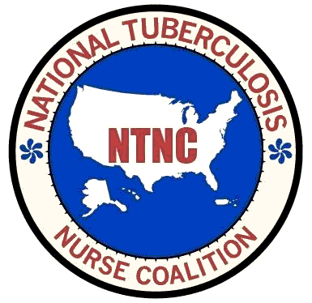

**National Tuberculosis Nurse Coalition**

**Membership Committee Chair Responsibilities**

**Purpose**

**The mission of the NTNC Membership Committee is to increase the number of tuberculosis nurses involved in National Tuberculosis Nurse Coalition and to increase access to other nurses with experience in care and treatment of tuberculosis patients**

**NTNC membership is open to all nurses who work in TB control programs, case manage TB patients, or are retired TB control staff members. All nurses who join as Associate Members of NTCA are members of the NTNC Section unless they declare in writing that they do not wish to be so included. All NTNC members have the right to vote, hold office, and serve on standing or special committees of the Section**

**The Responsibilities of the Membership Chair include but are not limited to:**

* **Monitor memberships and explore ways to increase membership**
* **Works closely with other committees to promote NTNC and enhance membership benefits**
* **Collaborate with the Education Committee to produce an annual webinar for non-members**
* **Hold regular meetings with committee members providing an agenda, updates and action items**